Yak Spark Soldering Project Assembly Instructions

# Solder the Xiao ESP32C3 module to U1

Tack the module into play by soldering only the top right pad. While applying heat to melt the solder, align the module and then remove heat. If you need to you can reheat the solder and re-align it. Once happy with the alignment, solder the remaining pads.

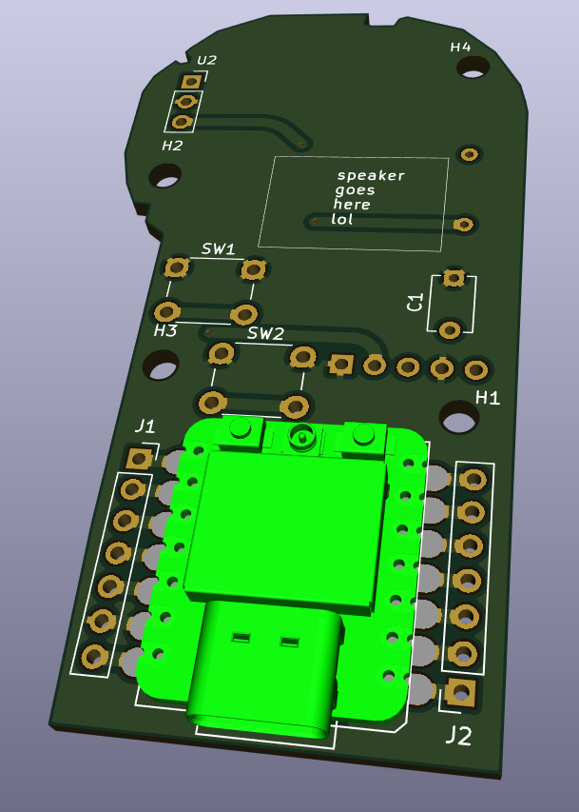

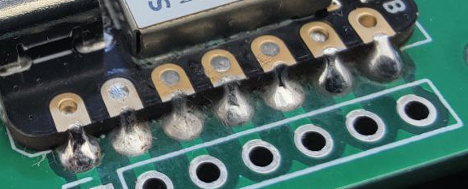

# Solder the Capacitor and Resistor to C1 and R1

Push the leads through the holes and bend them out slightly to hold the part in place. Flip the board over and solder each lead. Then clip the leads.

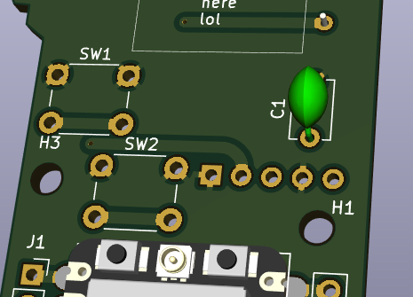

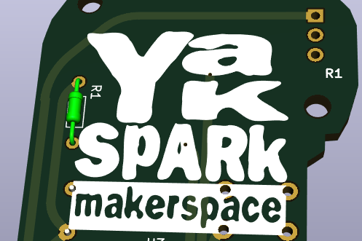

# Solder the Buttons to SW1 and SW2

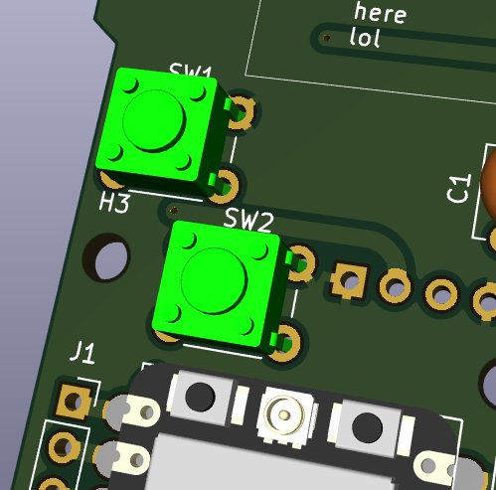

# Solder the Speaker to the Amplifier Board

Polarity doesn’t matter. It’s easiest to do this step while the amplifier is not yet soldered to the Yak Spark board.

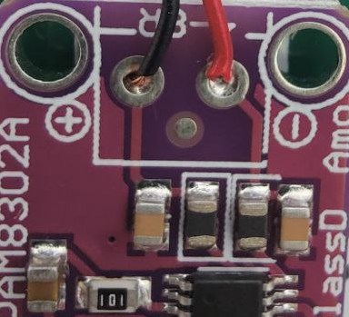

# Solder the Amplifier Board to U3

This is a two step process. Step one is to solder the pin header to the amplifier board and then solder them to the Yak Spark board.

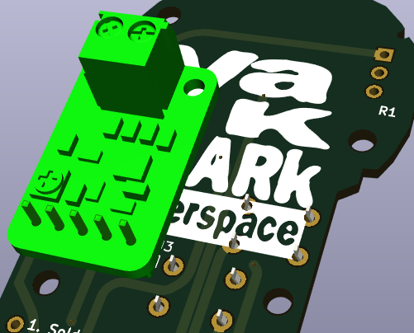

# Solder the Microphone Module to U2

Similar to the amplifier board, solder the pin header to the microphone board and then solder those to the Yak Spark board.

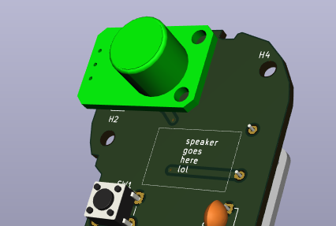

# Stick the Speaker to the spot on the front of the board

Peel the cover off of the adhesive and stick it right onto the board.

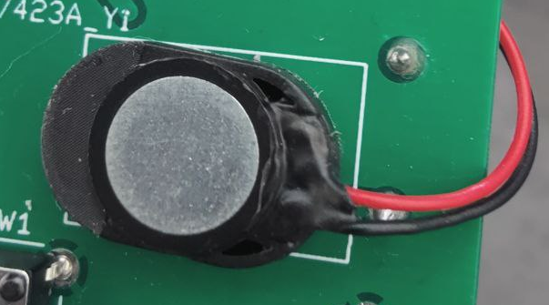

# Program it

Go to the **KEEPER OF THE CODE** and get the board programmed. See <https://yak.spark.lol> for more information about this project including the source code so you can hack it at home!